
ITX610B(R100)

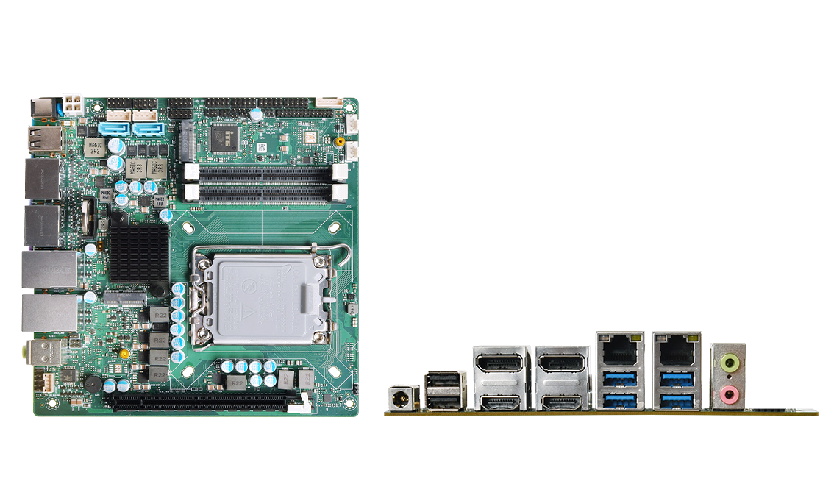

Product Features:
◆ Intel 12th generation Alder Lake-S series/13th generation Raptor Lake-s series, LGA1700, TDP 65W; H610/Q670;
◆ 2*DDR5 SO-DIMMs, up to 64GB;
◆ 2*Intel Network i219-LM + i226-V, 2*HDMI, 2*DP, DP/LVDS
◆ M-Key 2280，E-Key，PCIe_X16
◆ Power supply: DC 12-24V Size: 170x170 mm

Product specification
Processor system | Intel 12th generation Alder Lake-S series/13th generation Raptor Lake-S series, LGA1700, TDP 65W
Processor system | EFI BIOS
Memory | 2*DDR5 SO-DIMM 4800MHz, up to 64GB
Storage | 1*M.2 M-Key 2280 (NVMe PCIe4.0_x4 default / optional SATA3.0 protocol) storage interface
Storage | 2*SATA3.0 interface
Display | 2*HDMI2.1 interface, support 4096x2160@60Hz
Display | 2*DP1.4, support 7680x4320@60Hz
Display | eDP/LVDS
Board edge I/O interface | DC JACK, 2*USB2.0
Board edge I/O interface | 2*HDMI/DP
Board edge I/O interface | 2*(LAN + 2*USB3.2), 2-hole audio input and output
Extended Interface/Function | TPM2.0 optional, N/A by default
Extended Interface/Function | 1*PCIe_X16 (PCIe4.0_16x protocol)
Extended Interface/Function | 1*M.2 E-Key (PCIe3.0/USB2.0 protocol, support WIFI/BT module)
Extended Interface/Function | 4*COM pin header, 2x5Pin, pitch 2.54m; COM1/2 can choose RS232/485, COM3/4 can be RS232
Extended Interface/Function | 2 groups of 4 USB2.0 pin headers, with a pitch of 2.54mm (one USB2.0 and BT share LAY)
Extended Interface/Function | 8*GPIO header, 2x5Pin, pitch 2.54mm
Extended Interface/Function | 1*4Pin PWM CPU fan, 1*4Pin system fan
Power Supply | DC 12-24V, above 120W
Working Environment | Working temperature: -20℃ ~ +60℃; Working humidity: 5% ~ 90%
Working Environment | Storage temperature: -40℃ ~ +85℃; storage humidity: 5% ~ 90%
Operating System | Windows10, Windows11, Linux
Size | 170x170mm
weight | about 400g
ITX610B(R100)
产品尺寸 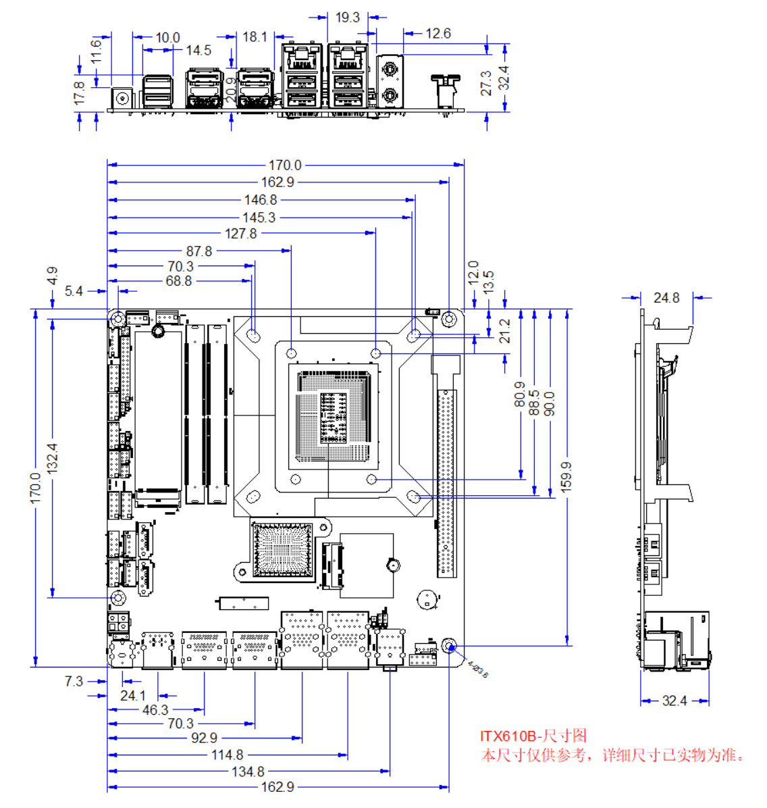 单位：mm

Ordering Information
Model | Options | Descriptions
ITX610B | External TPM2.0 | External TPM2.0 optional
ITX610B | Serial port COM1/2 optional 232/485 | RS232/RS485 optional
ITX610B | 1 set of USB2.0 pins | One set of USB2.0 pins and BT are optional
ITX610B | chipset | H610/Q670 optional
ITX610B | M.2 M-Key | PCIe4.0 x4/SATA3.0 protocol optional

